**Theorical explanation:**

# Accesibility of the web:

* 1.1.1 Non-text Content (meeted):
  + Technique H37: used to give a text alternative to the images, used in all the images of the web.
  + Technique Aria6: used to give a text alternative to the buttoms, for example, in the navigation menu.
* 1.4.1 Use of color (meted and advisored):
  + Technique C15: Is applied in the navigation var, when hovering the appearance is enhanced.
  + Technique G182: Is applied in the navigation menu, it is explained later in Accesibility improvements.

# Accesibility improvements:

* When hovering in the navigation var only color was used to enhance, and applying the technique G182 I made an styla enhancement in addition of the previous.

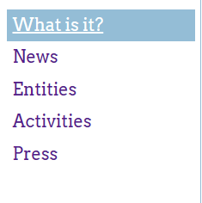Before:

After:

